**Azure devops cicd exam:**

1. creating the resource group

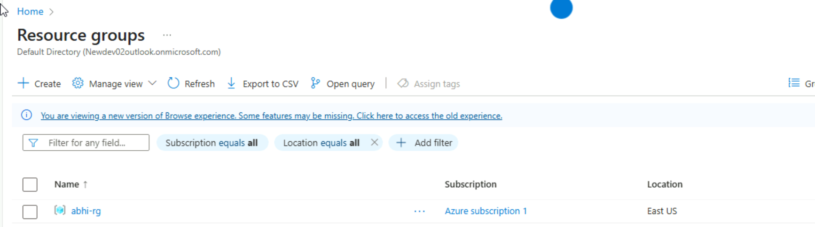

1. storage account mounted to do things in cloud shell

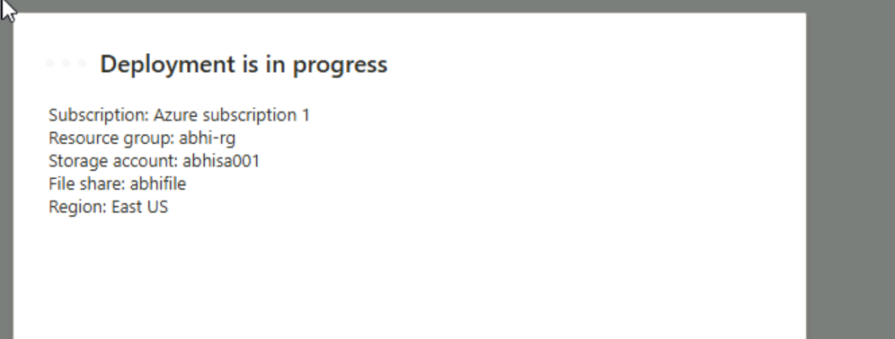

1. container registry created using az cli command

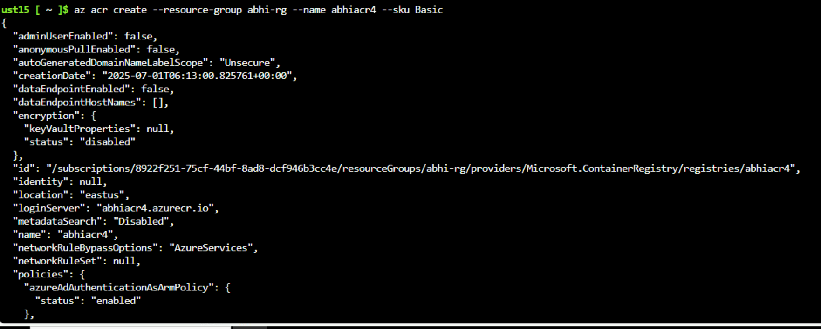

1. cluster creation:

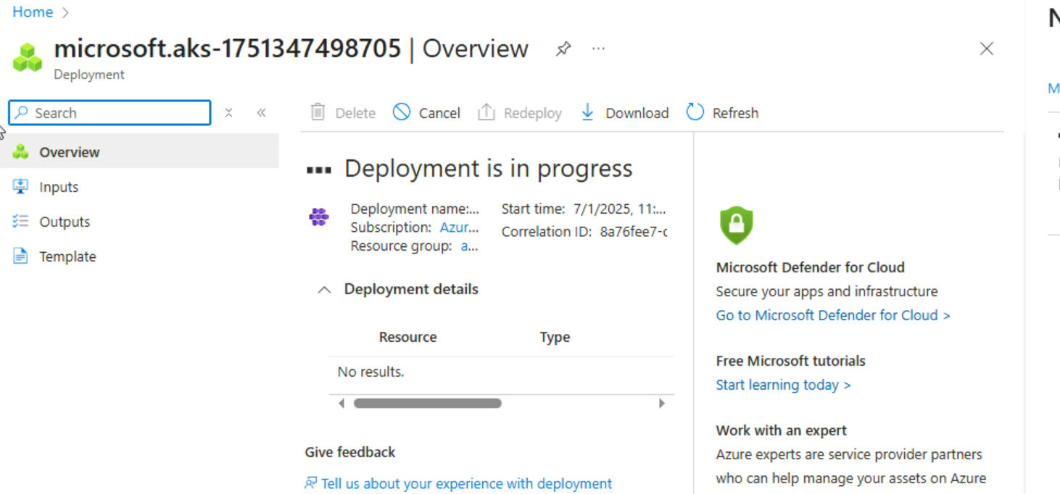

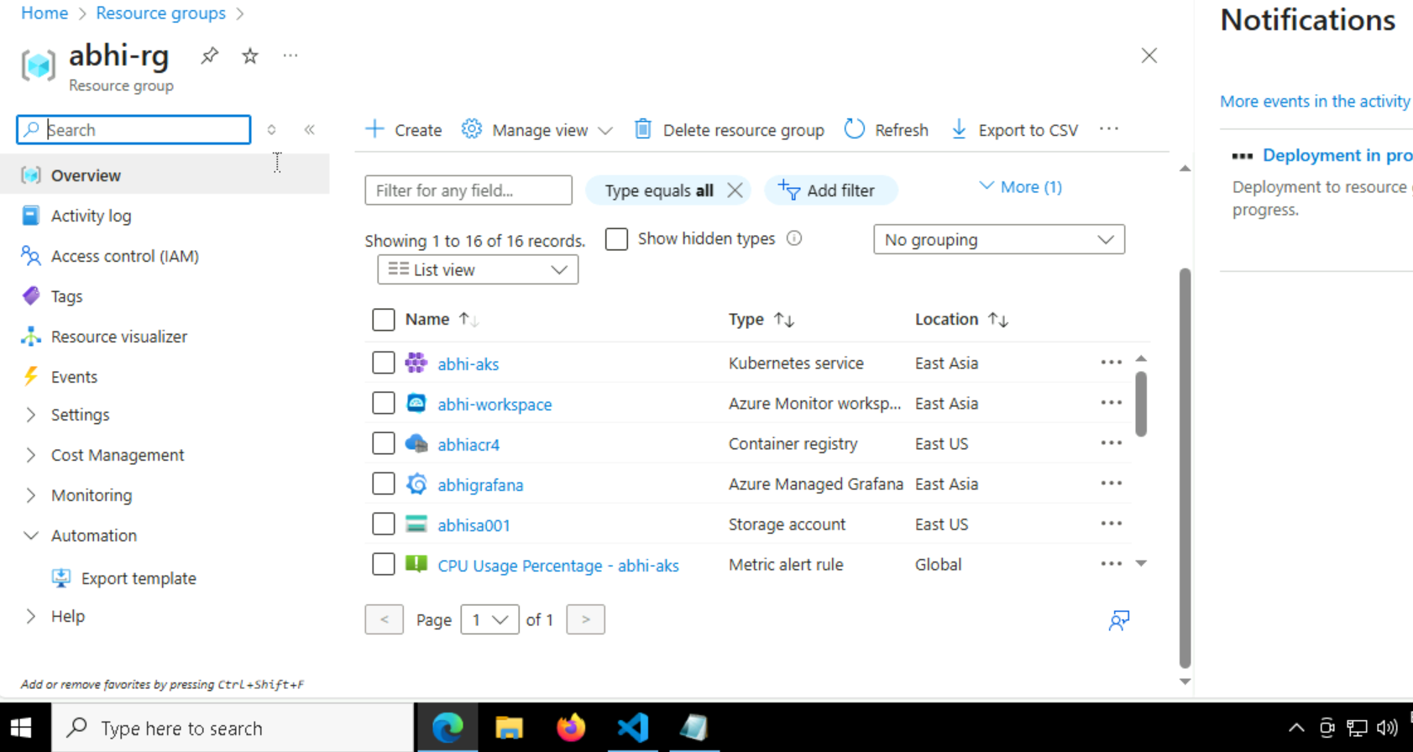

1. importing the nodejs git repo into azure devops:

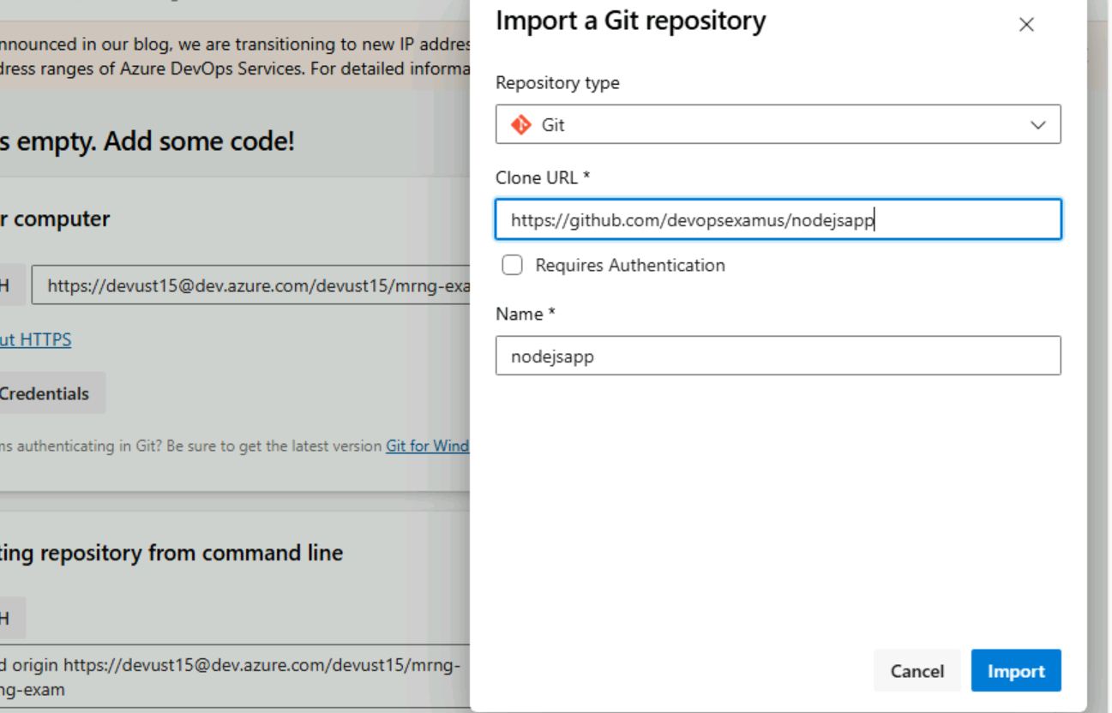

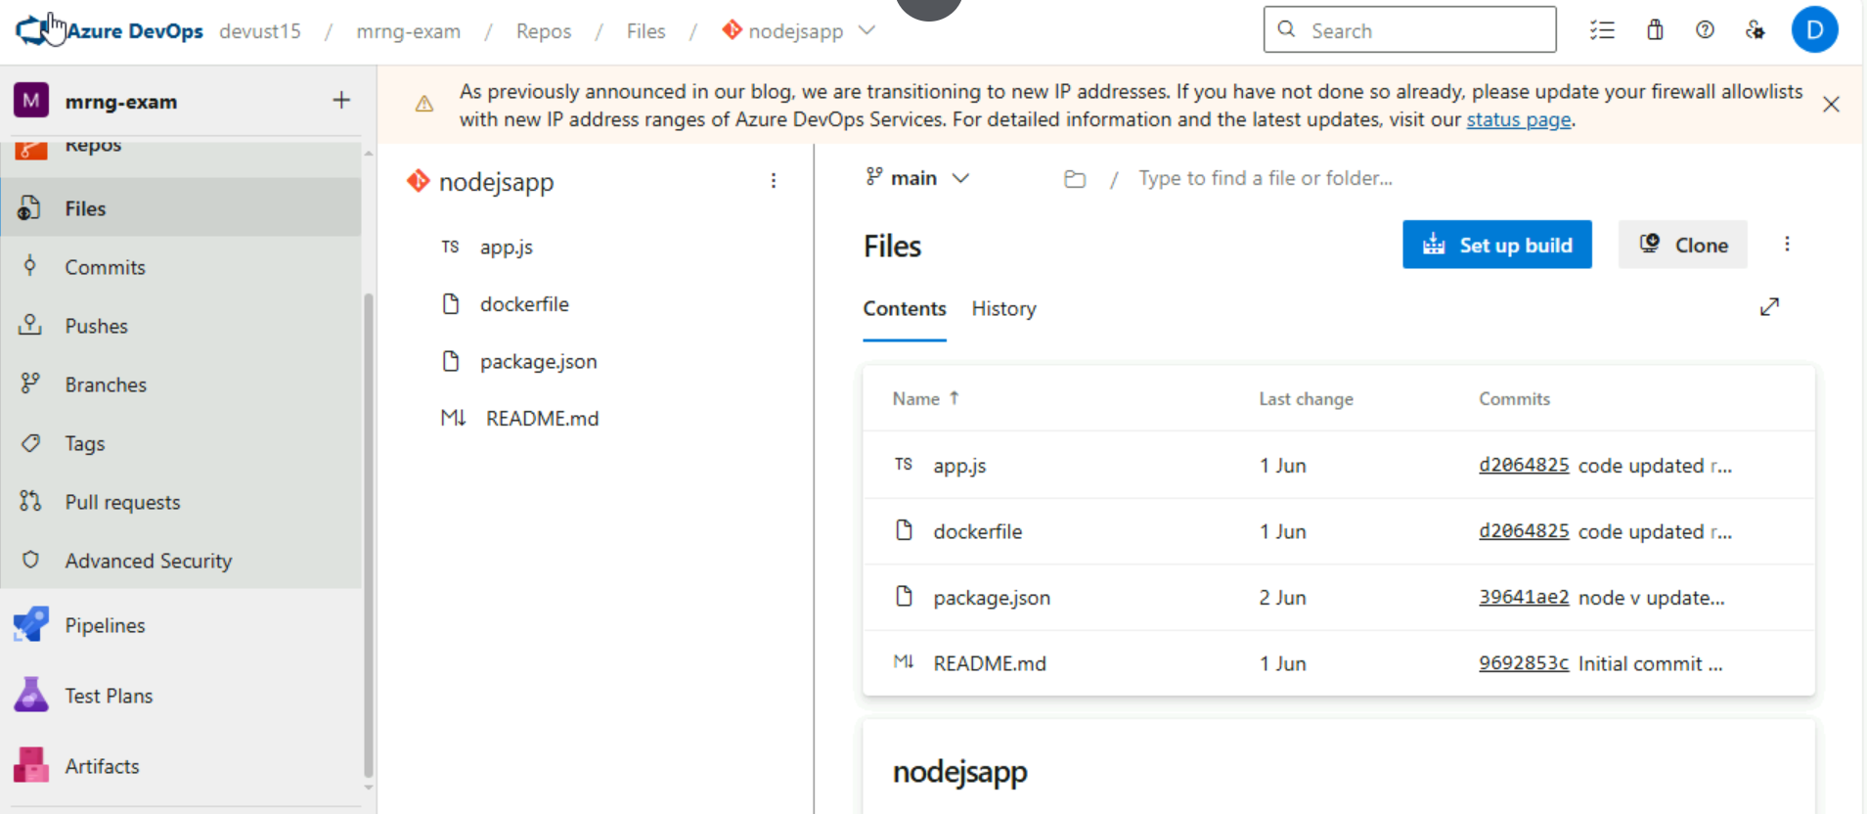

1. creating service connection:

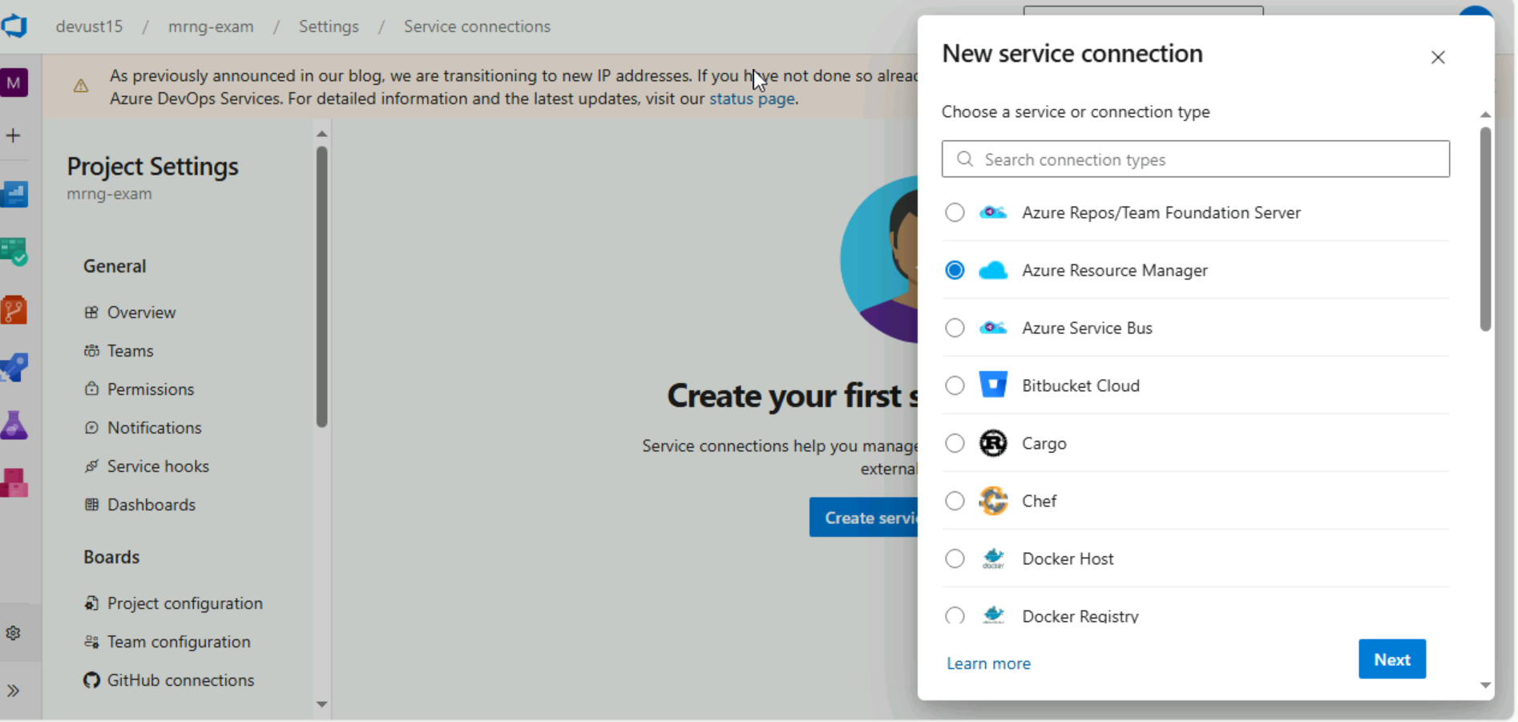

1. creating pipeline and got error:

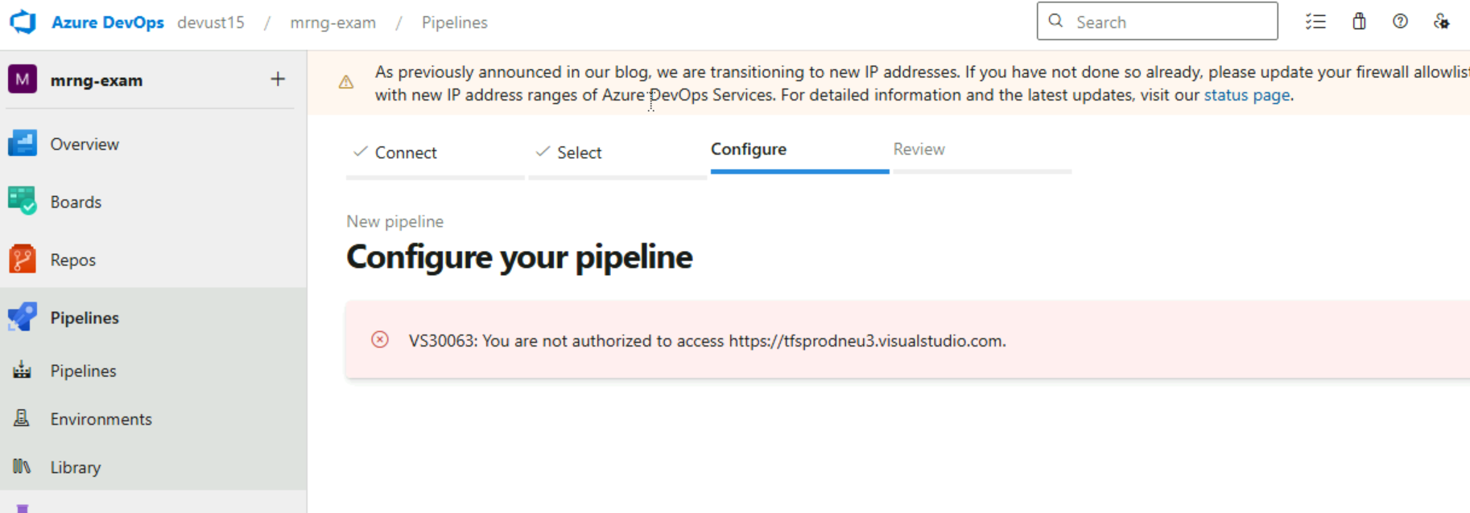

* I got stuck in this process for 50 mins and created a new organisation as per the instructions from hr

1. Creating pipeline

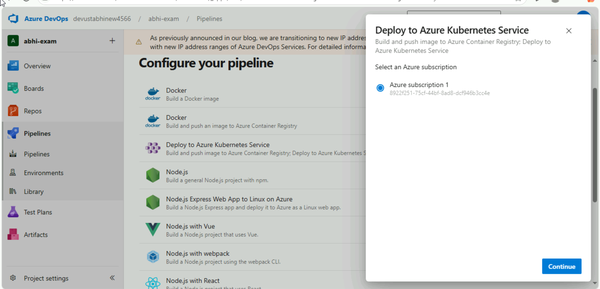

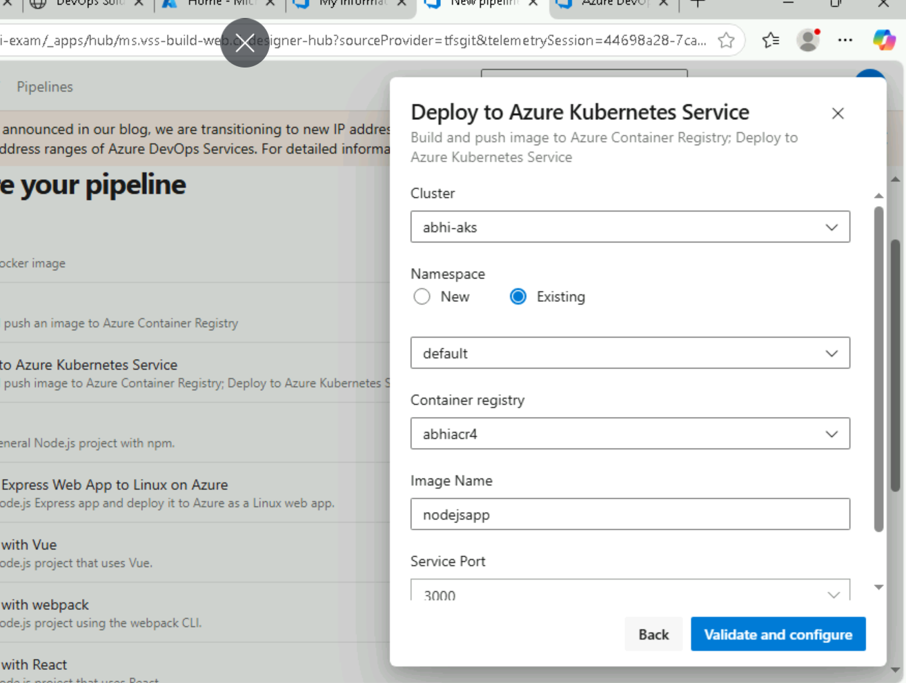

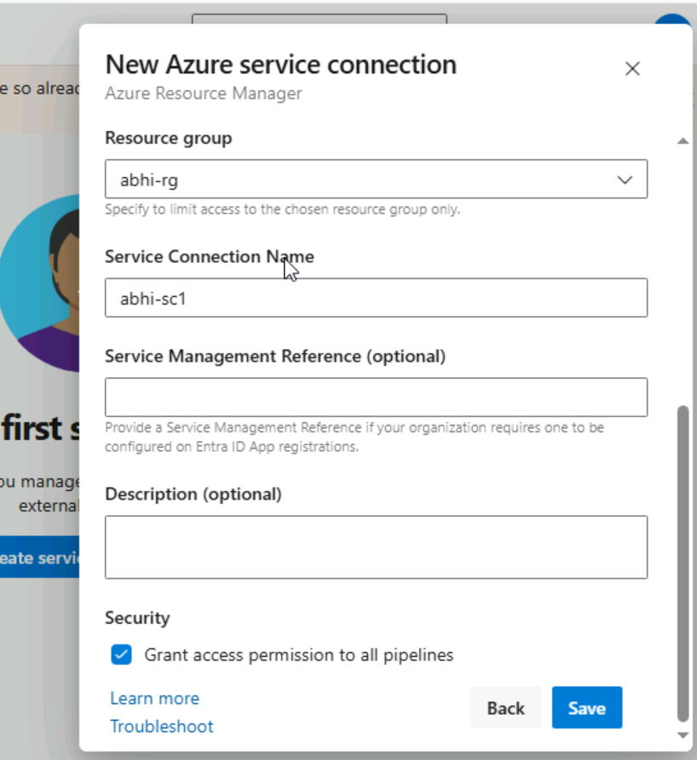

1. Created the agent

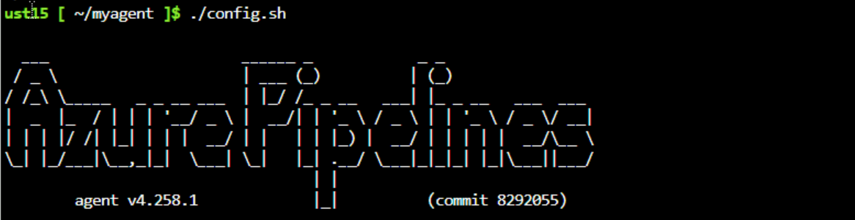

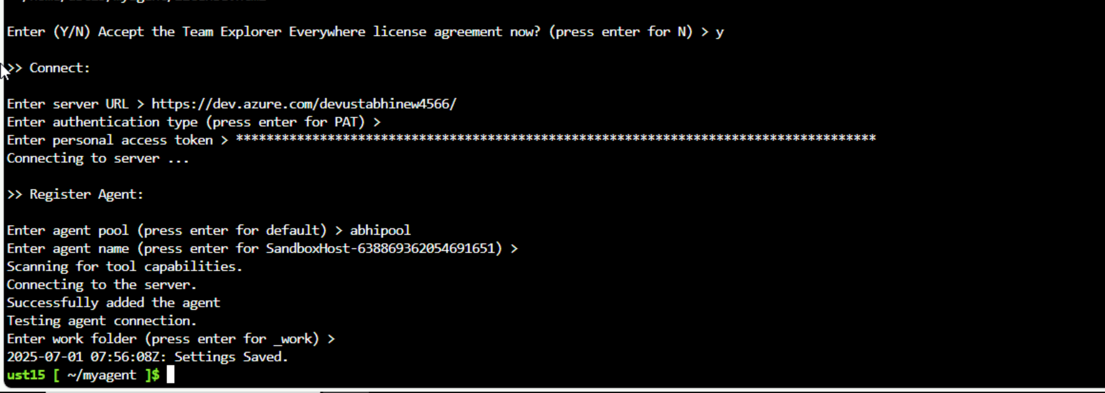

1. Making the agent active

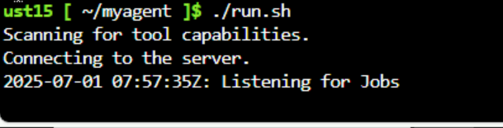

1. The agent came online:

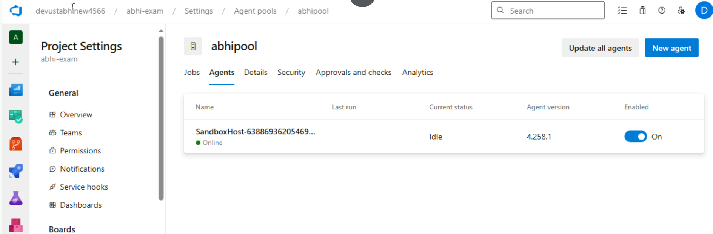

1. I m having an installation something issue from the lab team part

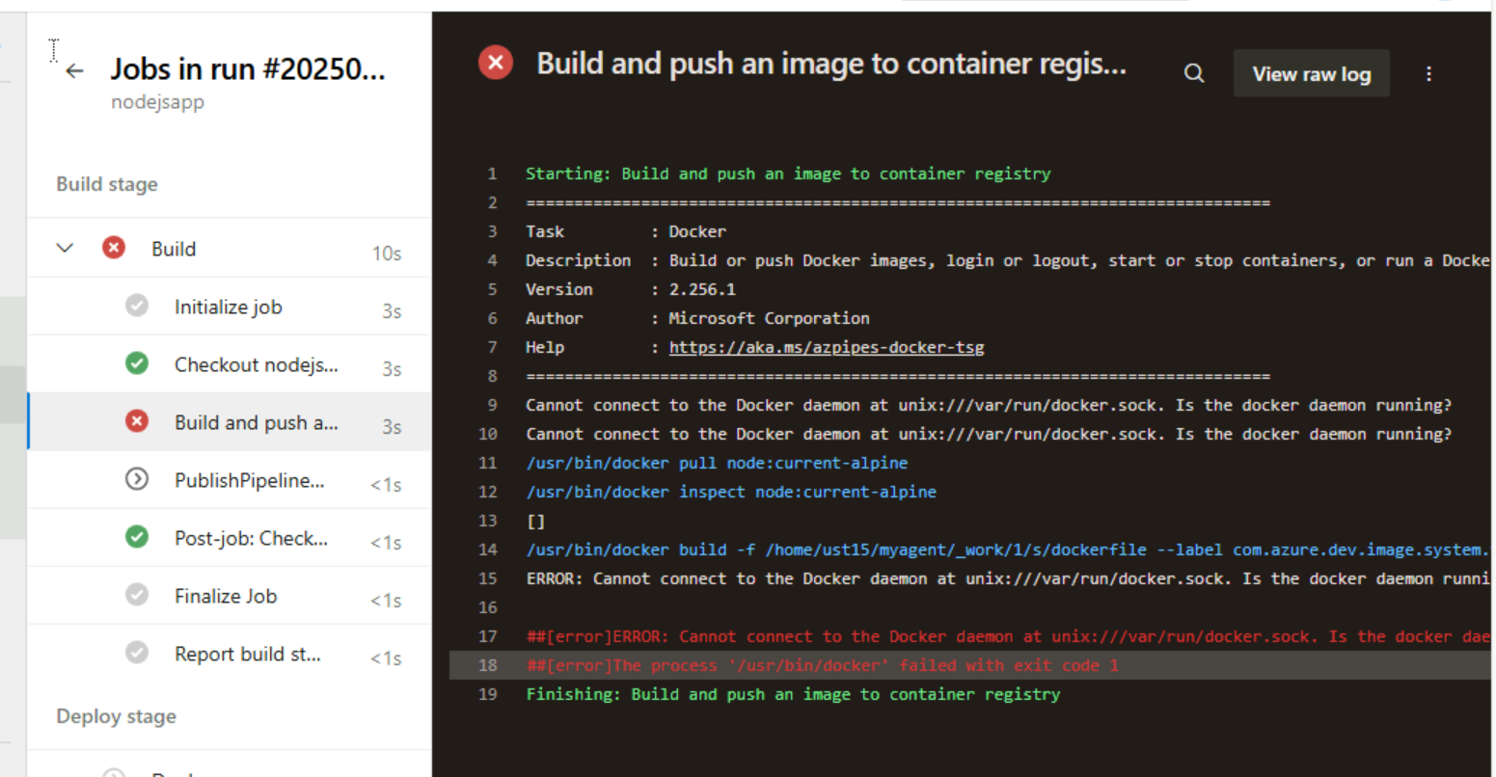

1. I tried to give the permssions to the docker but cant give

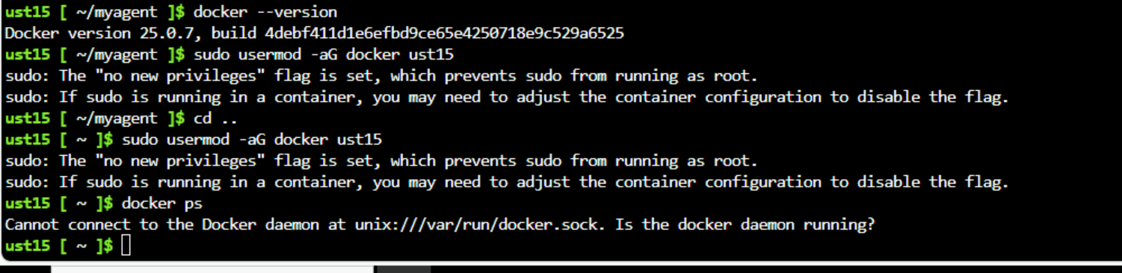

1. error

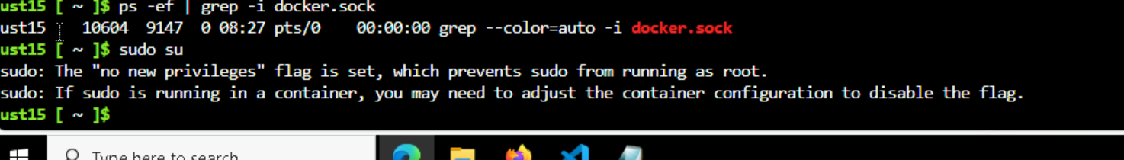

1. tried login the acr inside the agent

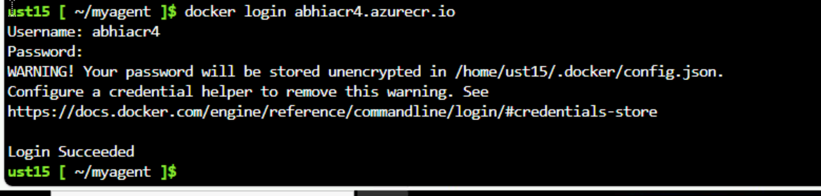

1. again tried login the acr in the workspace

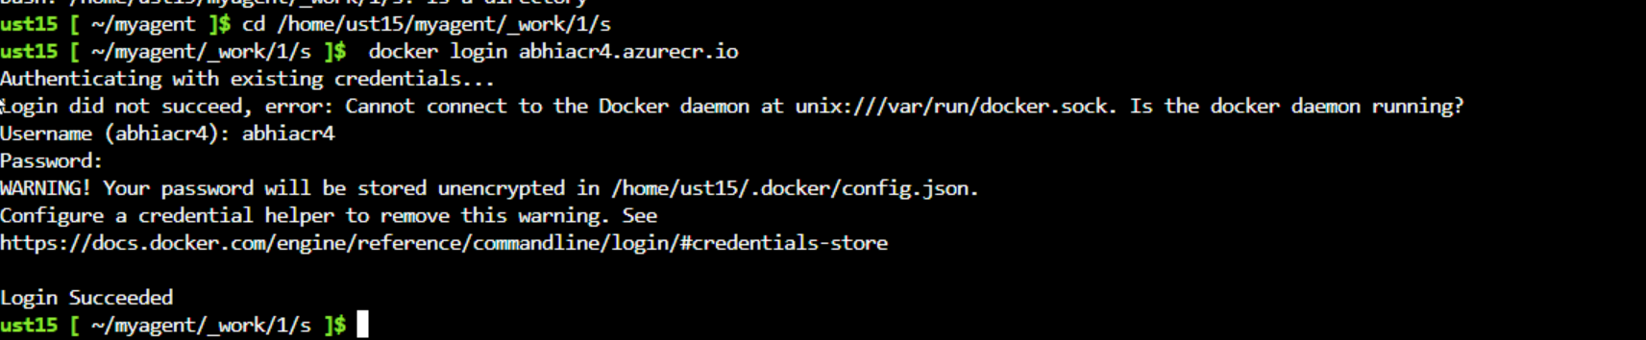

1. still the daemon is not running -> this is the issue when they install the docker…and not provider command sto reinstall docker
2. my pipeline.yml

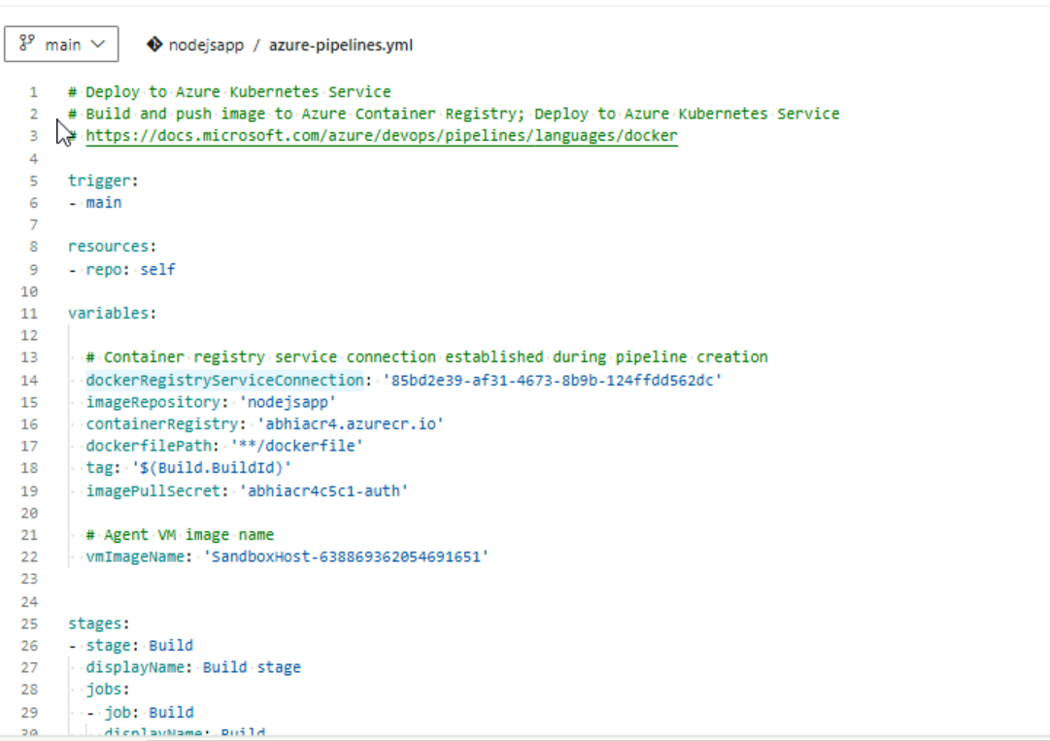

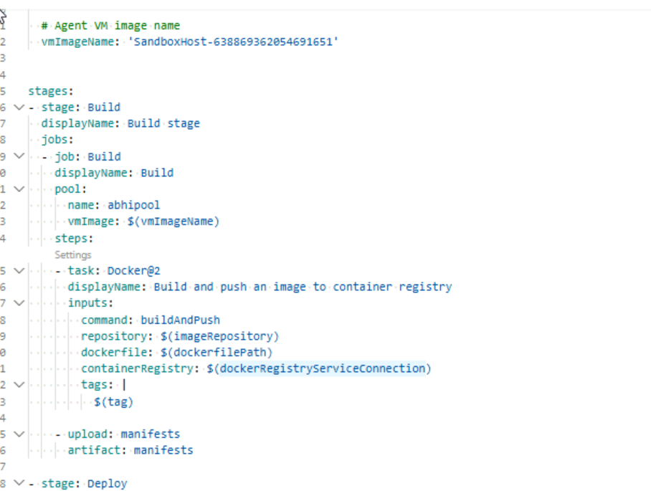

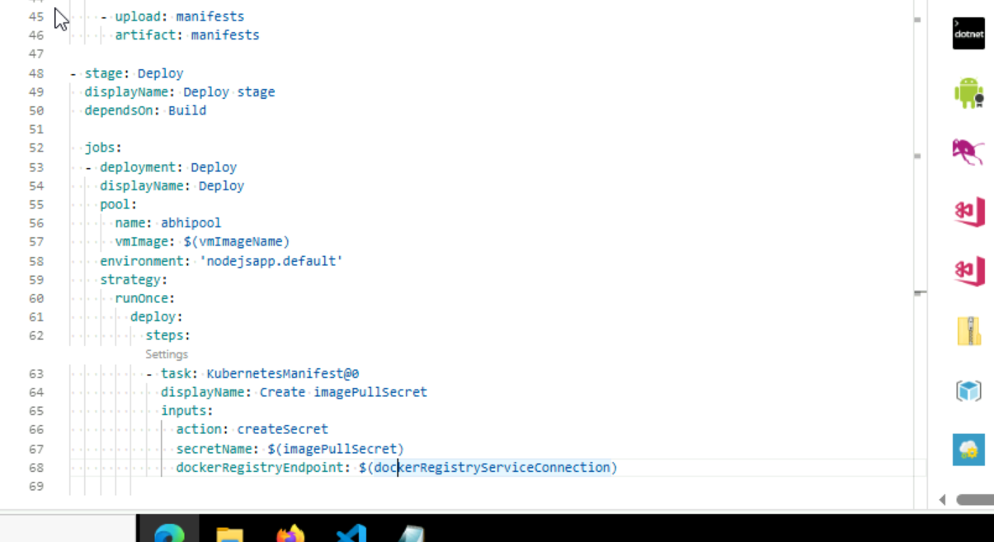

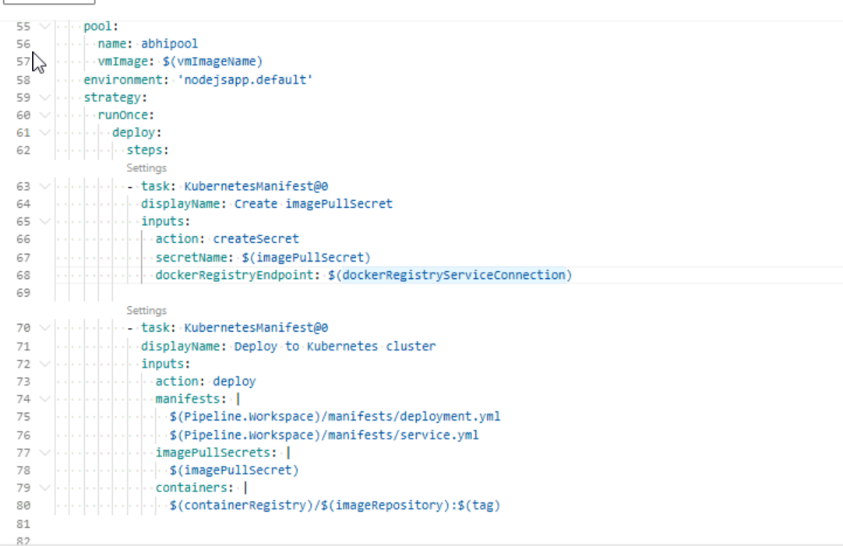

1. terraform code for the infrastructure I got from template:

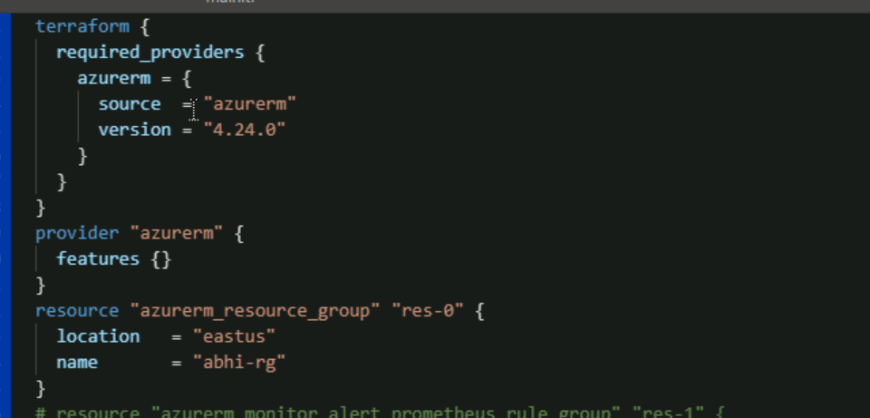

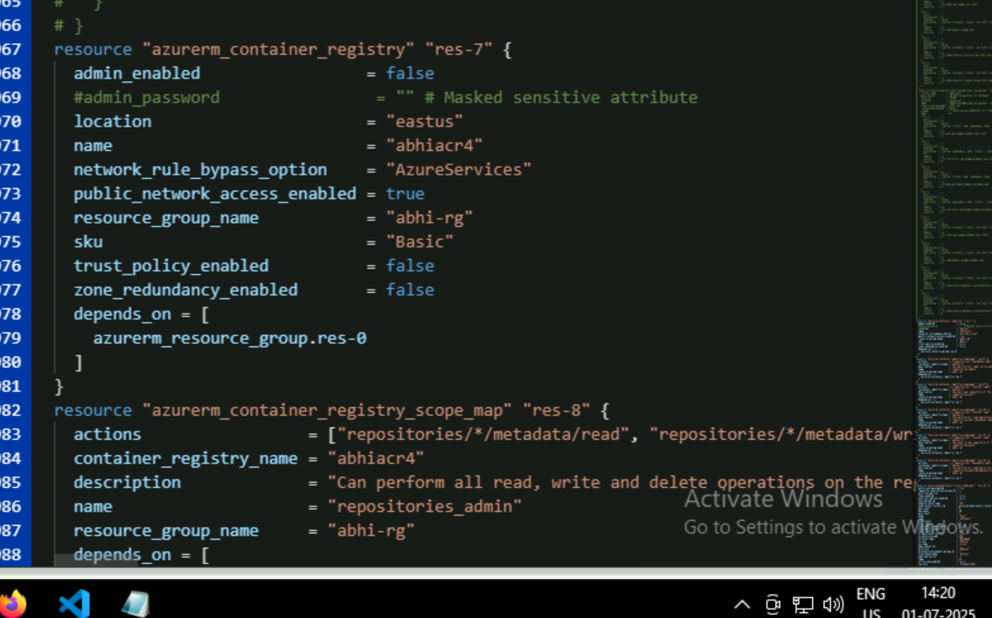

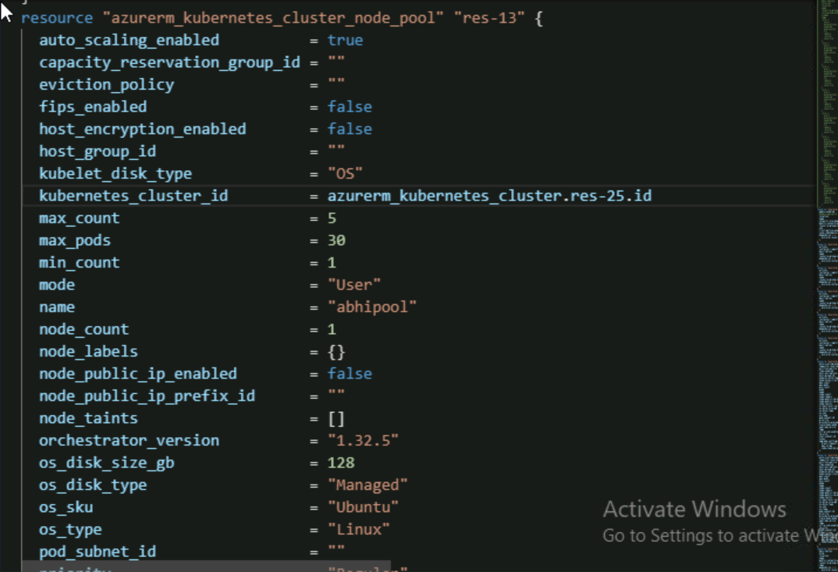

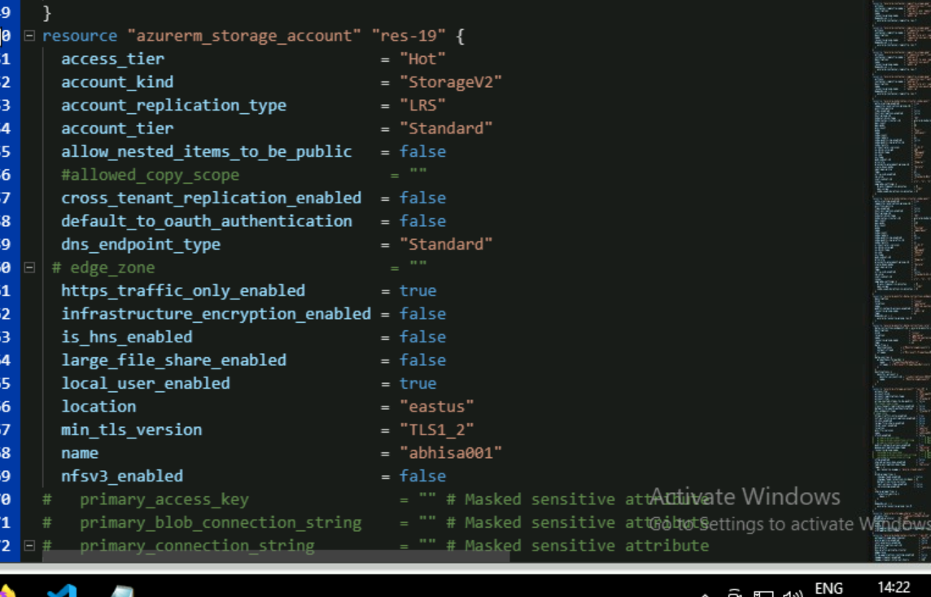

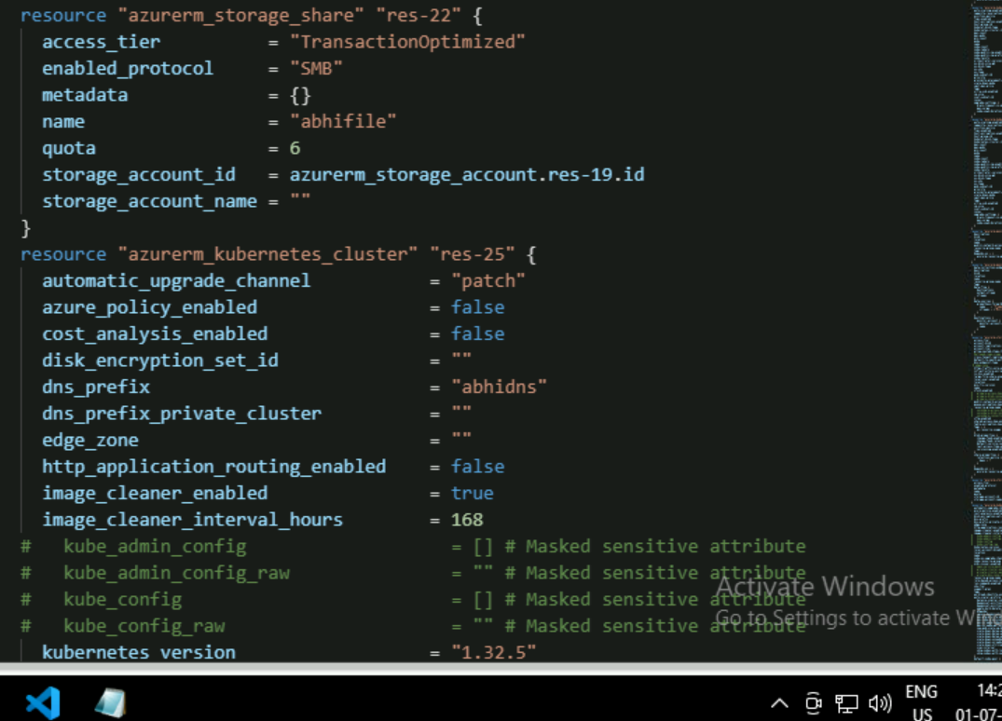

The code is very large I have involved the monitoring part also..and everything in my cluster

* prometheous
* Grafana
* Linked

1. Pipeline I have done will work fine if the docker daemon issue was not there
2. They are not ready to give the commands of docker installation
3. And I tried to trouble shoot these errors by assigning the user to the group docker
4. But no sudo privilege was there on my system
5. Its also raising an error
6. So please kindly check out my pipeline
7. The pipeline is correct and working fine

Dockerfile:

